Figure 1: Hole A Upper Roodepoort quartzite logging features with outliers data points marked in color red .(a) Natural gamma.(b) Density. (c) Vp. (d) Vs.

Figure 2: Hole A Lower Roodepoort metasiltstone logging features with outliers data points marked in color red.(a) Natural gamma.(b) Density. (c) Vp. (d) Vs.

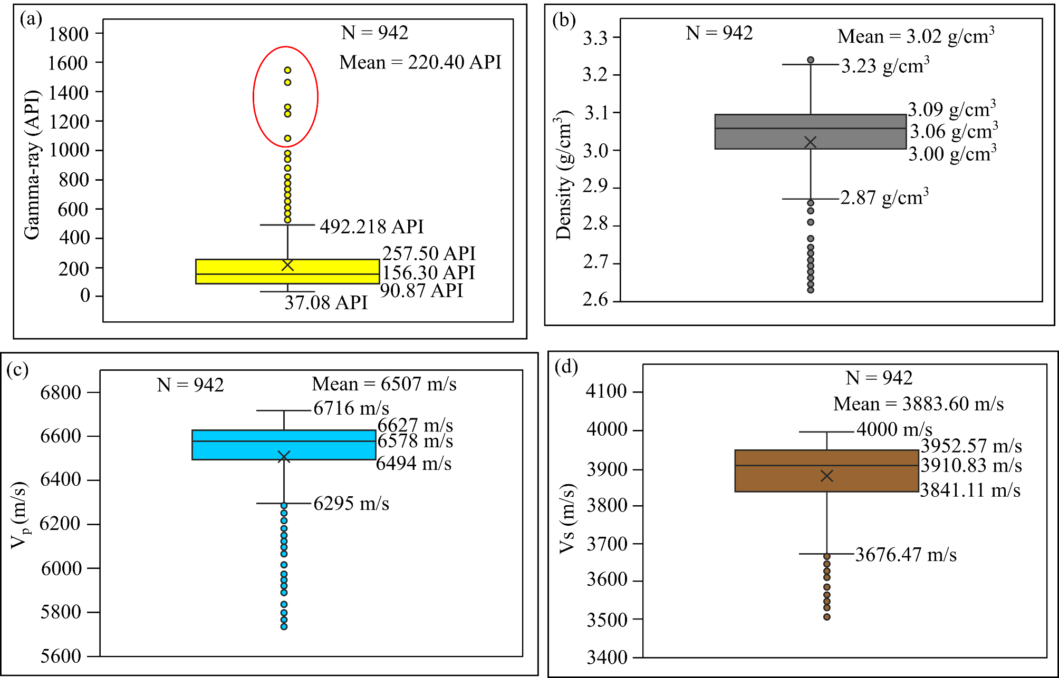

Figure 3: Hole A Lower Roodepoort diabase intrusion logging features with outliers data points marked in color red.(a) Natural gamma.(b) Density. (c) Vp. (d) Vs.

Figure 4: Hole A Lower Roodepoort quartzite logging features with outliers data points marked in color red.(a) Natural gamma.(b) Density. (c) Vp. (d) Vs.

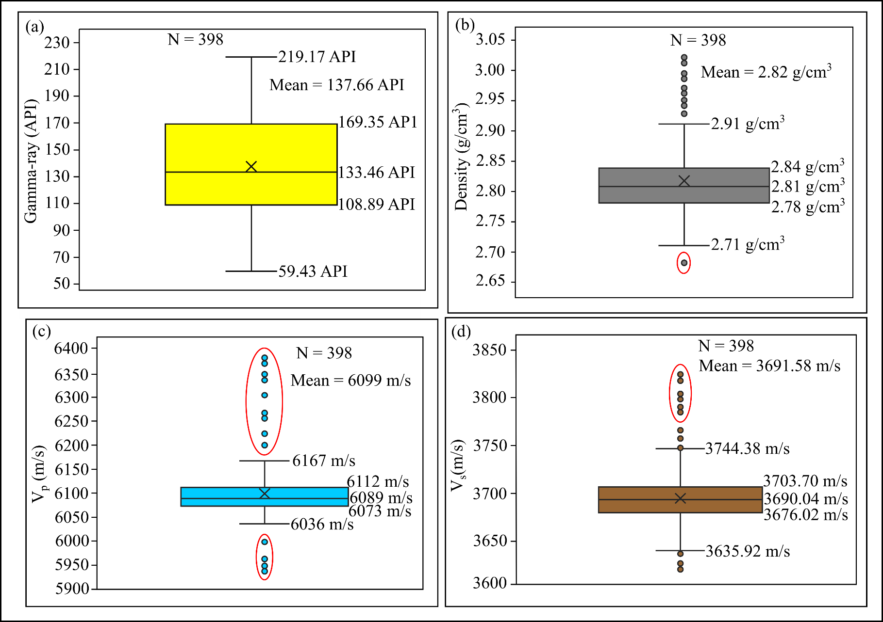

Figure 5: Hole A first strata of Crown basalt logging features with outliers data points marked in color red.(a) Natural gamma.(b) Density. (c) Vp. (d) Vs.

Figure 6: Hole A Crown diabase intrusion logging features with outliers data points marked in color red .(a) Natural gamma.(b) Density. (c) Vp. (d) Vs.

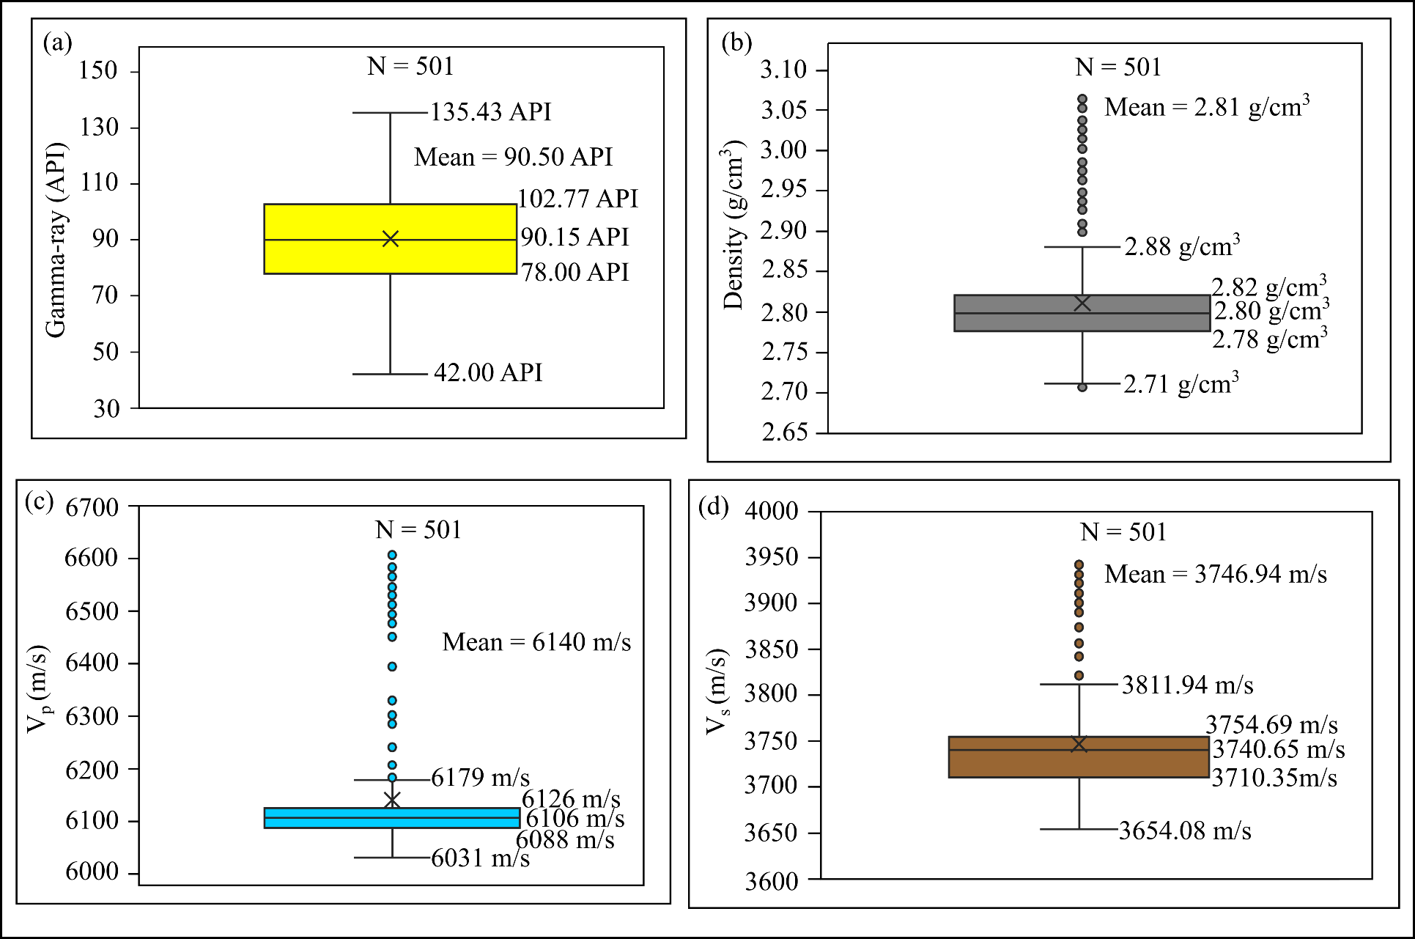

Figure 7: Hole A second strata of Crown basalt logging features with outliers data points marked in color red.(a) Natural gamma.(b) Density. (c) Vp. (d) Vs.

Figure 8: Hole A first layer of Babrosco quartzite logging features with outliers data points marked in color red .(a) Natural gamma.(b) Density. (c) Vp. (d) Vs.

Figure 9: Hole A Babrosco basalt logging features with outliers data points marked in color red.(a) Natural gamma.(b) Density. (c) Vp. (d) Vs.

Figure 10: Hole A second strata of Babrosco quartzite logging features with outliers data points marked in color red.(a) Natural gamma.(b) Density. (c) Vp. (d) Vs.